Justice in decarbonizing the heating system consistent with the Paris Climate Agreement: subsidy balance between landlords and tenants at the multi-apartment building level

# Introduction

* Europa bis 2050 klimaneutraler Kontinent
* Maßnahmen bis 2030 CO2 um mindestens 55% reduzieren (1990)
* Gerechte und nachhaltige Zukunft gewährleisten
* *Leaving no one left behind*
* Wir wissen „low hanging fruits“ und wo es schwer wird
* Besonders herausfordernd im Wärmesektor, aus verschiedenen Gründen
  + High shares of fossil fuels in the (low temperature) heating sector
  + Verschiedene Besitzverhältnisse der Endkunden   
    🡺 Mehrparteienhäusern und Urbanisierung
* Besonderes Augenmerk: historischer Entwicklung gesehen habe zum Beispiel bei PV Durchdringung 🡺 Einspeiseförderung kam bei jenen an, die Dachfläche hatten und Mieter in Mehrparteienhäusern nicht, weil keine Dachfläche vorhanden.
* Against this background, the core objective of this work:
  + Die Rahmenbedingungen für einen ökonomischen und sozial ausgeglichen Heizsystemwechsel eines Mehrparteienhaus zu untersuchen.
  + Damit verbunden sind insbesondere die unterschiedlichen Besitzverhältnisse eines Mehrparteienhaus.
  + Wie können diese sozial ausgeglichen werden auf Gebäudeebene?

The main research question is which

Investitions- und Heizkostenzuschuss, Mietpreisobergrenze gekoppelt an das Heizsystem sind für den Vermieter bzw. Mieter notwendig um aus ökonomischer Perspektive einen Heizsystemwechsel sinnvoll zu machen?

# State of the Art

## Sozial-ausbalancierte Investitionen in Erneuerbare Energien

## Umstellung der Heizsysteme auf lokaler Ebene (Gebäudeebene)

## Progress beyond state of the art

(Mundaca, Busch, & Sophie, 2018):

“We examine two local energy transitions from an energy justice perspective.”

## Paper comparision

|  |  |  |  |  |  |  |
| --- | --- | --- | --- | --- | --- | --- |
| ***Paper*** | ***Non-cooperative game theory*** | ***Cooperative game theory*** | ***Technology*** | | | ***Multi-Objectives*** |
| ***Renewable Generation*** | ***Demand Response*** | ***Energy Storage*** |
| (Adika and Wang 2014)[1] | X |  |  | X | X |  |
| (Alam et al. 2013)[2] |  | X (Shapley Value) | X |  | X |  |
| (AlSkaif 2016)[3] |  | X (Repeated energy sharing Game) | X |  | X |  |
| (Atzeni et al. 2013)[4] | X | X |  | X | X | X |
| (Avrachenkov et al. 2015)[5] |  | X  (Nash bargaining) |  |  |  |  |
| (Barbato et al. 2011)[6] | X | X | X | X | X |  |
| (Chakraborty et al. 2015)[7] |  | X  (Coalition game theory) | X |  | X |  |
| (Dehghanpour and Nehrir 2017)[8] |  | X  (Nash bargaining) | X | X | X | X |
| (Ferris and Liu 2016)[9] | X |  |  | X |  |  |
| (Gao et al. 2014)[10] | X  (Nash equilibrium) |  | X | X | X |  |
| (Gao et al. 2015) | X |  |  | X |  |  |
| (Hajiloo et al. 2016)[11] |  | X  (Nash bargaining) |  |  |  | X |

# Methodology

### Objective function

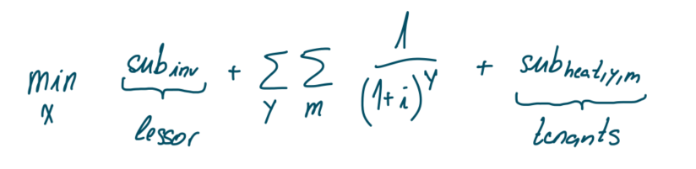

### Constraints

#### Demand constraint

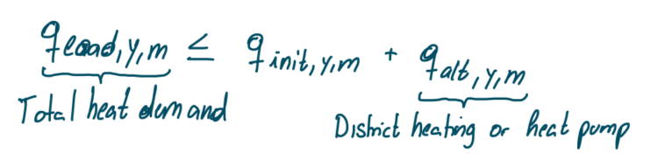

#### Installed heating system capacity

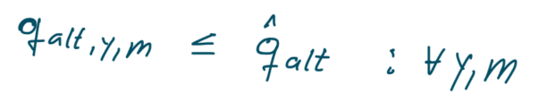

#### Investment costs of the landlord

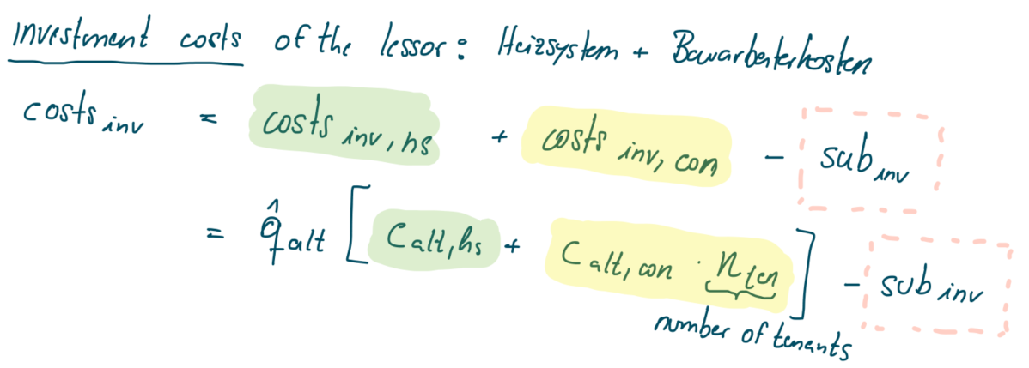

#### Operational revenues of the landlord



#### Net present value constraint of the landlord

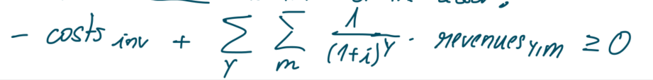

# Numerical example

# Discussion

# Conclusions

# References

Mundaca, L., Busch, H., & Sophie, S. (2018). ‘Successful’ low-carbon energy transitions at the community level? An energy justice perspective. *Applied Energy*, 292-303.

1. Non-Cooperative Decentralized Charging of Homogeneous Households' Batteries in a Smart Grid
2. Cooperative energy exchange for the efficient use of energy and resources in remote communities.
3. Thesis topic 2: A Distributed Energy Sharing Framework among Households in Microgrids based on a Repeated Game Approach.  
   Thesis topic 3: A Reputation-based Energy Sharing Framework for Microgrids with a Shared Energy Storage Unit
4. Noncooperative and Cooperative Optimization of Distributed Energy Generation and Storage in the Demand-Side of the Smart Grid
5. Cooperative network design: A Nash bargaining solution approach
6. Cooperative and Non-Cooperative House Energy Optimization in a Smart Grid Perspective
7. Real-time energy exchange strategy of optimally cooperative microgrids for scale-flexible distribution system
8. Real-Time Multiobjective Microgrid Power Management Using Distributed Optimization in an Agent-Based Bargaining Framework
9. Modelling demand response in organized wholesale energy markets
10. Game-Theoretic Energy Management for Residential Users with Dischargeable Plug-in Electric Vehicles
11. Nash Bargaining Approach to Design Multi-Objective MPC